**Name: salini K.B**

**Roll No:33**

**Batch:B**

**Date:21-3-2022**

**NETWORKING & SYSTEM ADMINISTRATION LAB**

**Experiment No.: 1**

**Aim**

Install the latest version of Ubuntu on an Oracle VM VirtualBox.

**Procedure**

1. Download and Virtualbox Windows 10 Installation

2. Ubuntu ISO download

3. Install Virtualbox

4. Create an Ubuntu VM

5. Install Ubuntu on Virtualbox Windows 10

6. Install Virtualbox Guest Additions

## Download and Virtualbox Windows 10 Installation

## Install Ubuntu on VirtualBox

## 2. How To Install Ubuntu On Virtual Box?

### 2.1. Open VirtualBox

### 2.2. Click on “New” to create a virtual machine

### 2.3. Enter Name for your Virtual Machine

### 2.4. Select “Linux” Operating System from “Type”

### 2.5. Click “Next”

### 2.6. Enter amount of memory (RAM) =1024 MB and click “Next”

### 2.7. Click “Create” to create hard drive

### 2.8. Click “Next”

### 2.9. Click “Next”

### 2.10. Enter Size of Virtual Hard Drive= 20 GB and Click “Create”

### 2.11. Select Virtual Machine

### 2.12. Click on “Start” to start the virtual machine

### 2.13. Select disk file source

### 2.14. After selecting the OS file to be installed click “Open”

### 2.15. Click “Start”

### 2.16. Click “Ok”

### 2.17. Click “Install Ubuntu”

### 2.18. Click “Continue”

### 2.19. Click “Install Now”

### 2.20. Click “Continue”

### 2.21. Select location and click “Continue”

### 2.22. Select keyboard layout & click “Continue”

### 2.23. Fill all the details and Click “Continue”

### 2.24. Now the installation process will start and installation window will appear

### 2.25. Click “Restart Now”

### 2.26. When the system will get restarted the following message will appear. Press “Enter”

### 2.27. Close the pop-up messages by clicking on the Close (×) button

## 3. Steps To Maximize The Size Of Ubuntu Desktop

### 3.1. Go to “Devices”

### 3.2. Click “Insert Guest Additions CD Image…”

### 3.3. Click “Run”

### 3.4. Click “Authenticate”

### 3.5. Press “Enter”

### 3.6. Now “Restart” your system for the changes to be applied.

### 3.7. After the system gets restarted. Go to “View”

### 3.8. Click “Switch to Fullscreen”

### 3.9. Click “Switch”

**Output Screenshot**

**Step 1:** [Download VirtualBox](https://www.virtualbox.org/wiki/Downloads) for Windows and install it on your computer

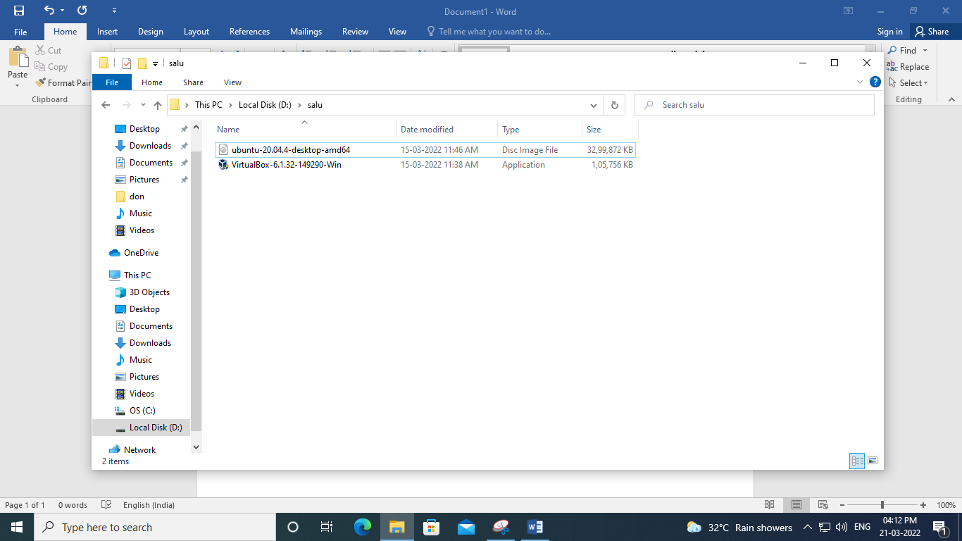



INSTALL UBUNTU VIRTUAL BOX

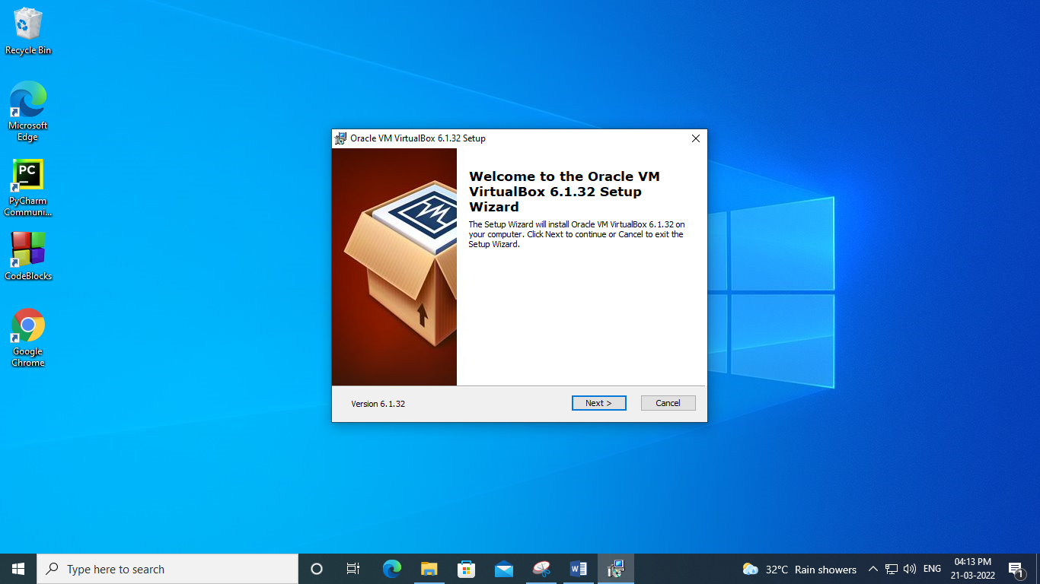

CLICK NEXT

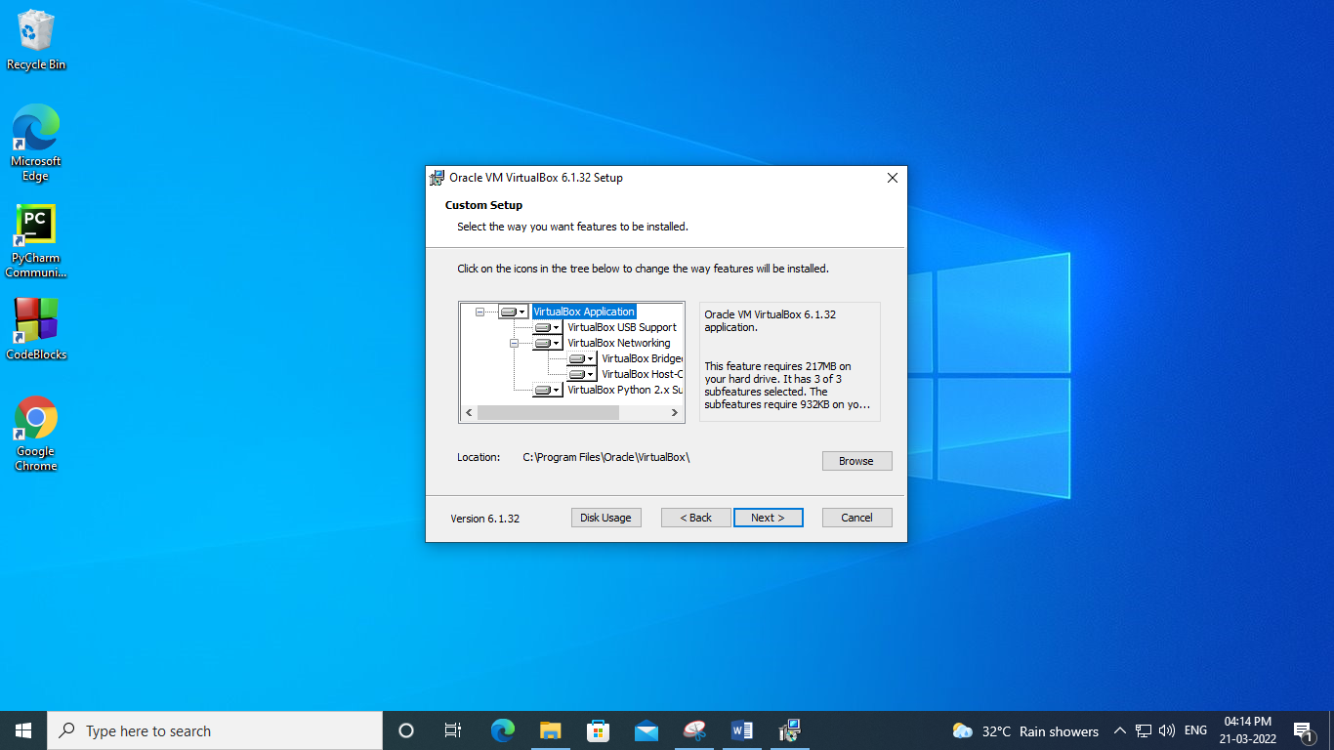

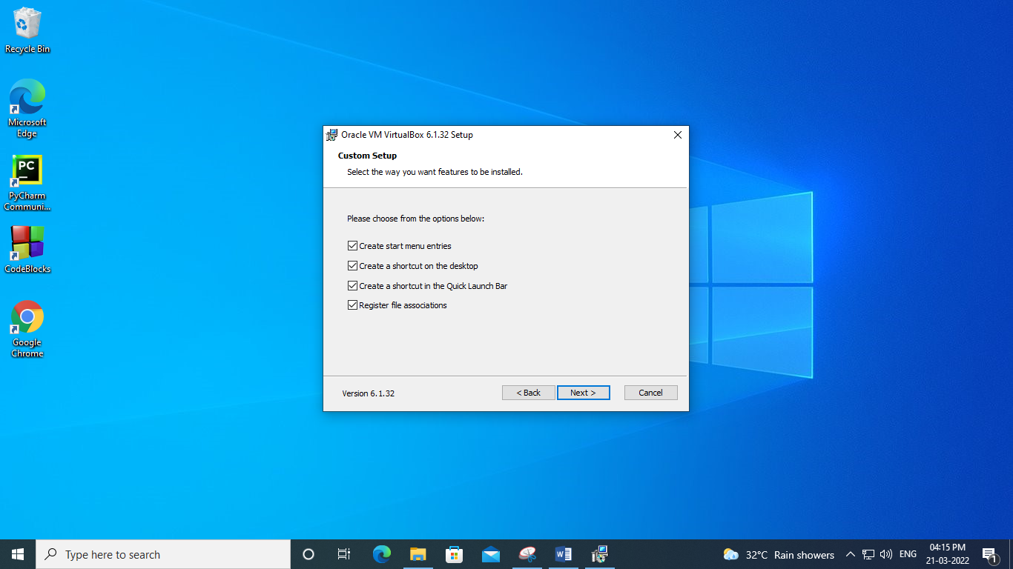

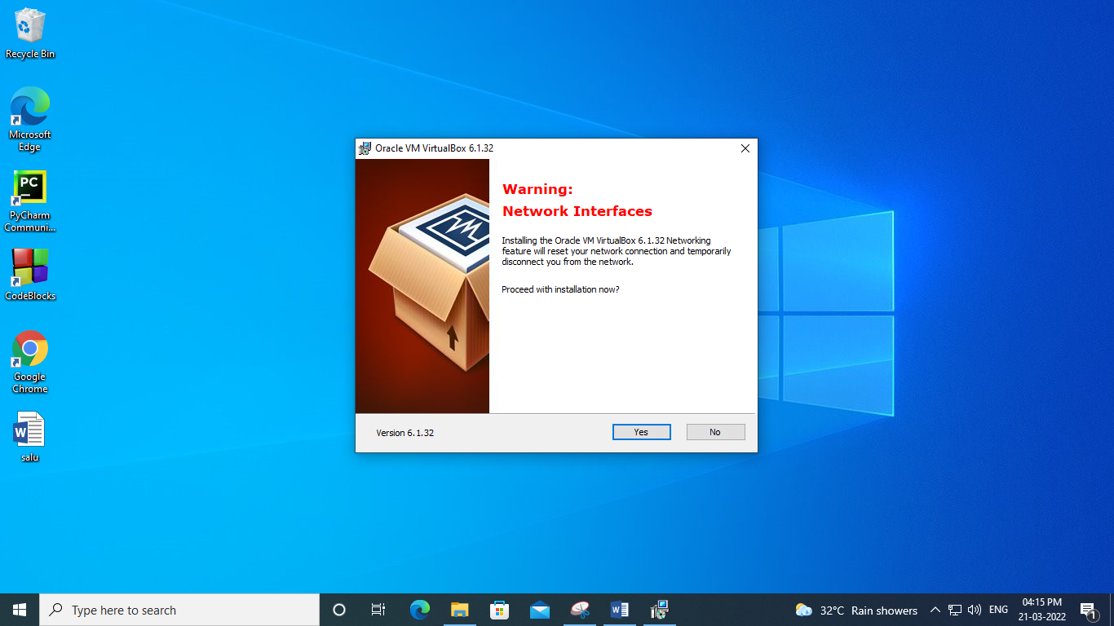

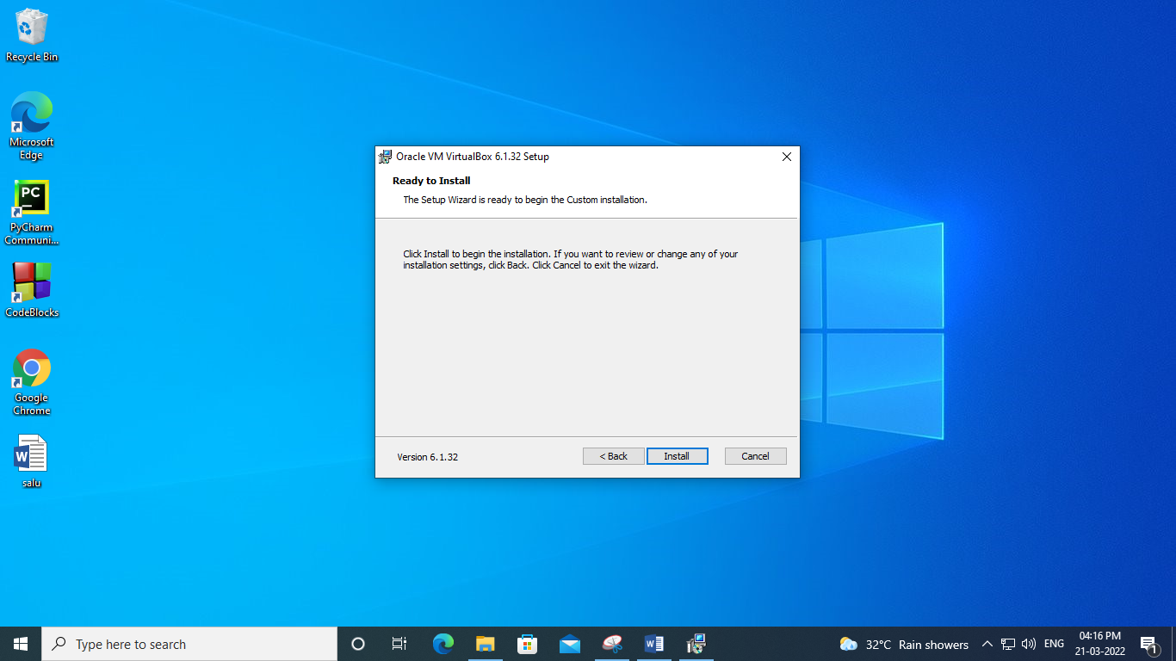

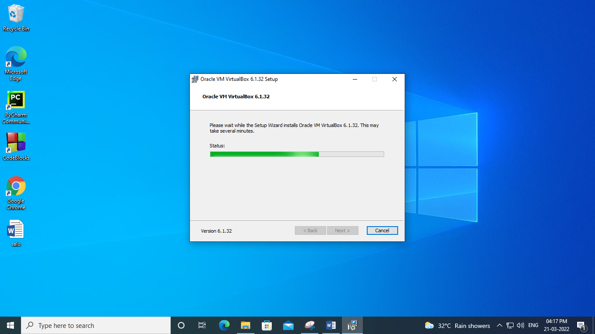

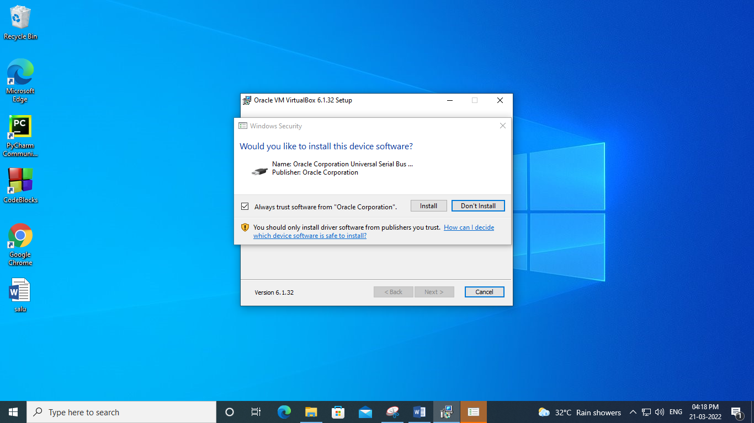

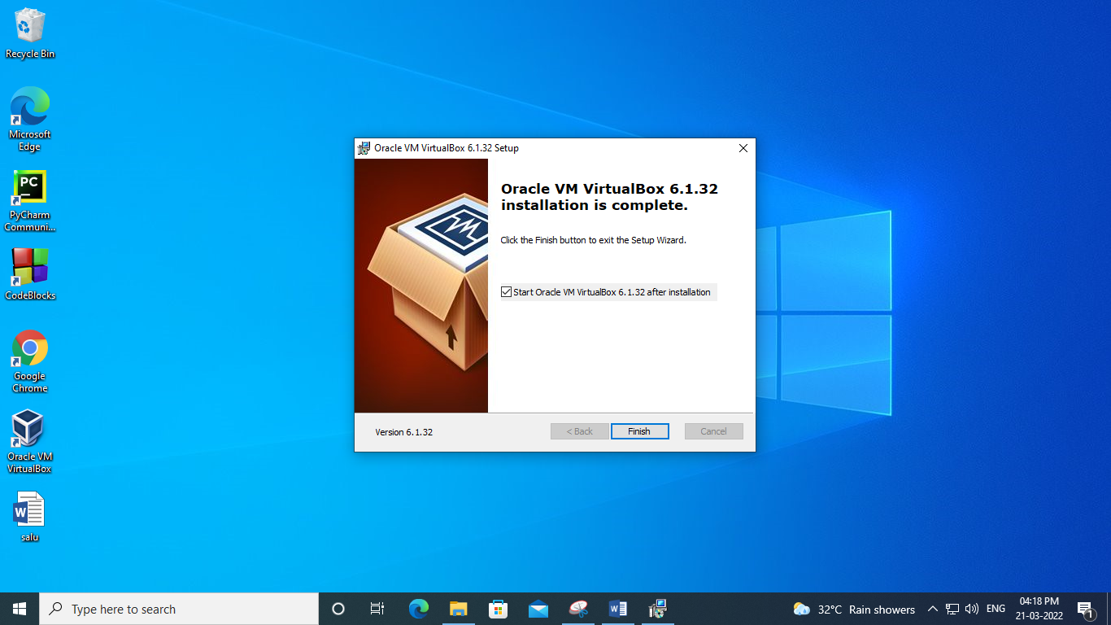

**Step 2:** Open VirtualBox and select New in the top taskbar.

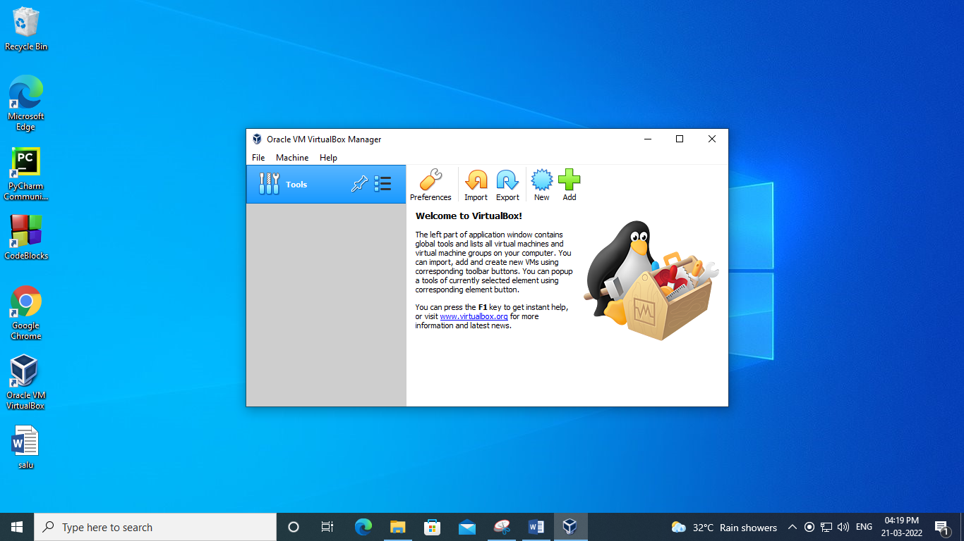

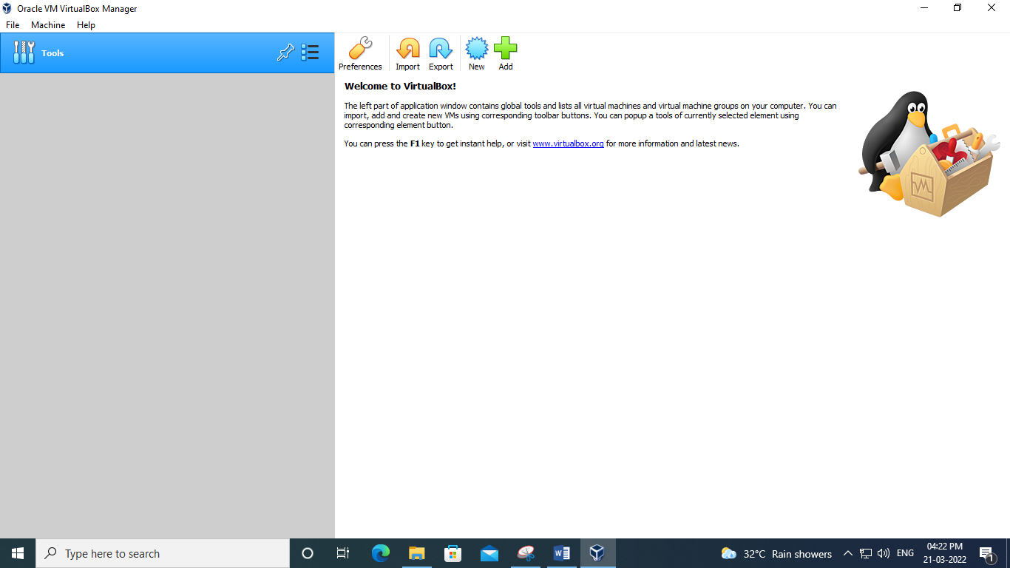

**Step 3:**Give your VM a name, choose Linux as the Type, then choose Ubuntu as the Version and select Next.

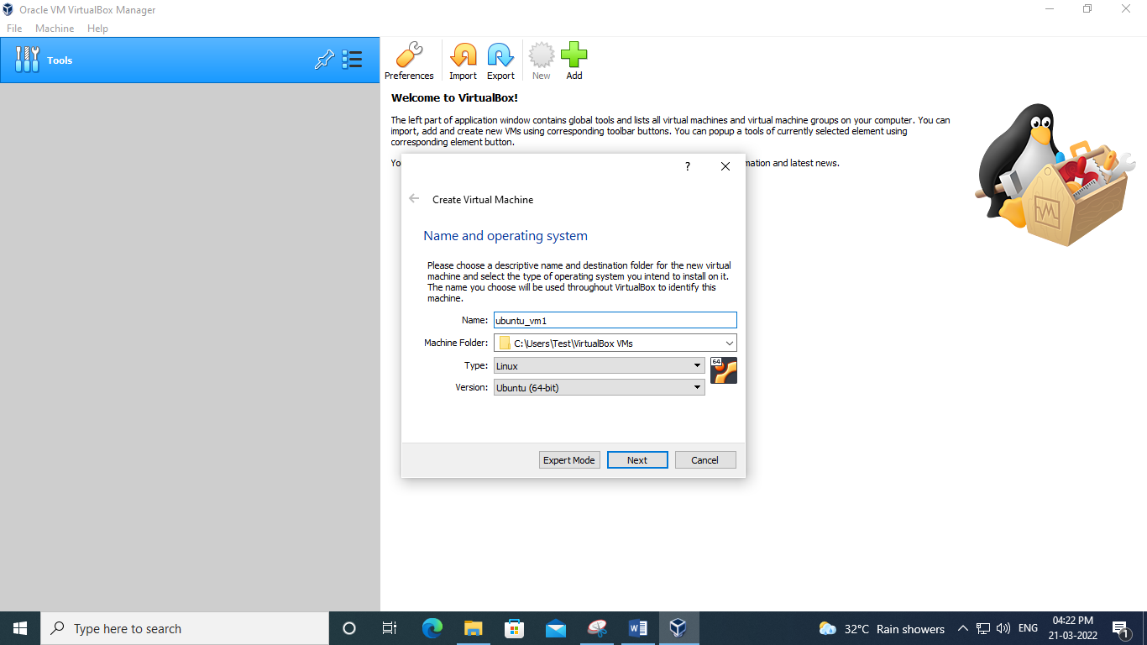

**Step 4:**Choose how much [RAM](https://www.lifewire.com/what-is-random-access-memory-ram-2618159) you want to assign to the virtual machine and select Next. The recommended minimum is 1024 [MB](https://www.lifewire.com/what-is-a-megabit-2483412)

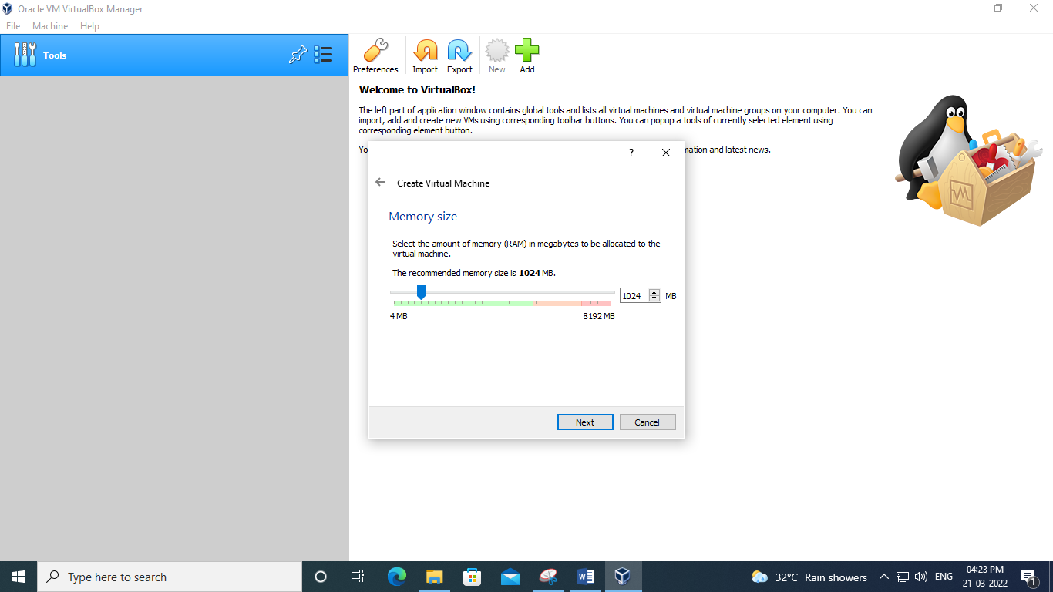

**Step 5:**Choose Create a virtual hard disk now and select Create.

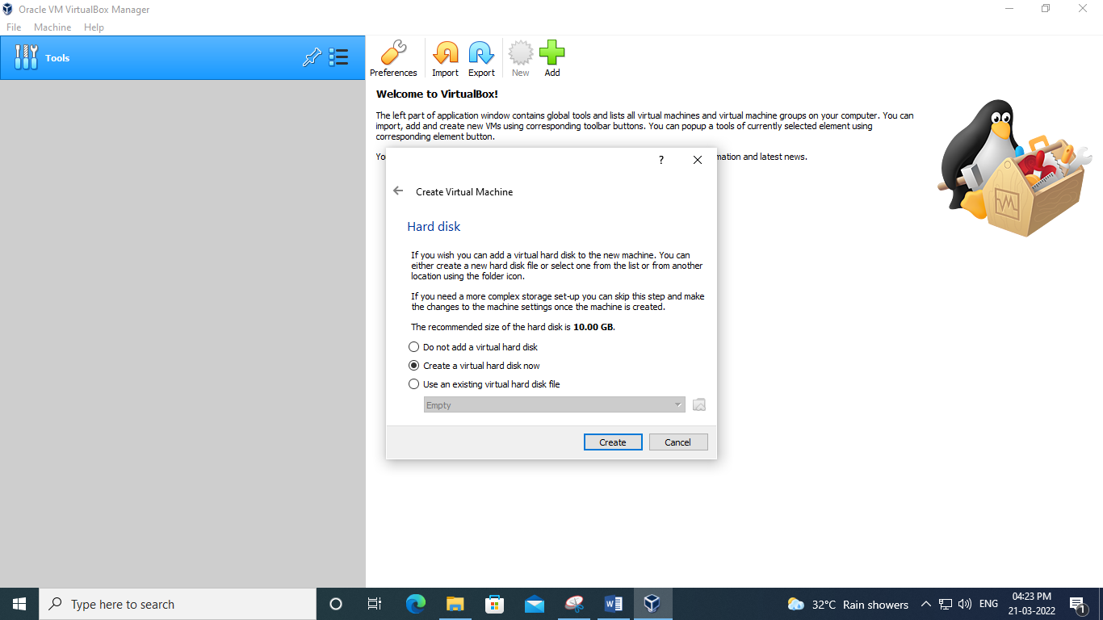

**Step 6:**Choose VDI (VirtualBox Disk Image) and select Next

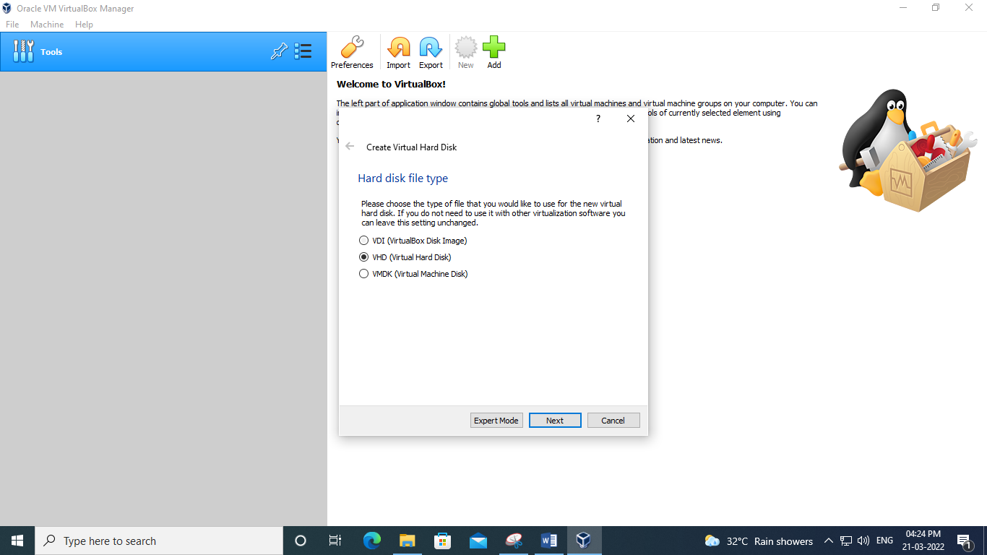

**Step 7:**Choose Dynamically allocated or Fixed size for the storage type and select Next.

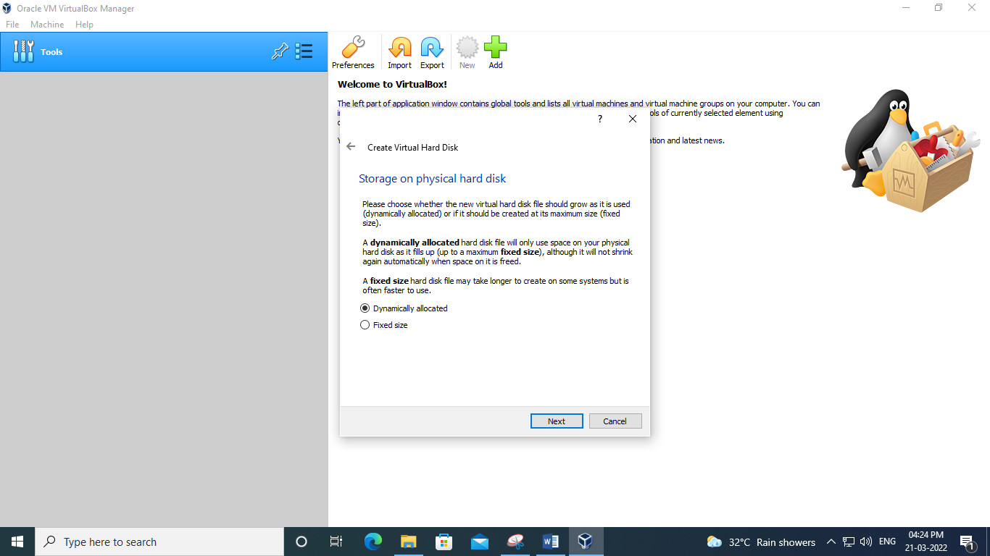

**Step 8:**Choose how much space you wish to set aside for Ubuntu and select Create.

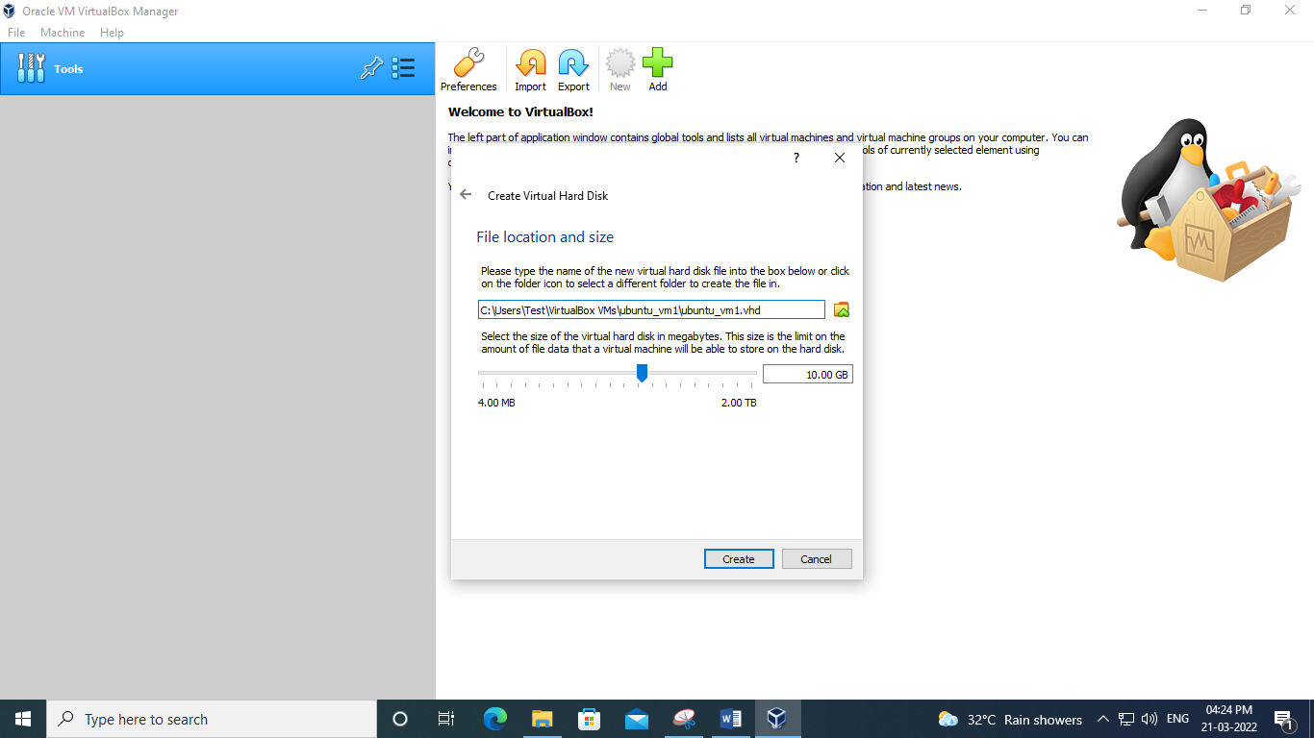

**Step 9:**The name of our virtual machine will now appear on the left side of the VirtualBox manager. Select Start in the toolbar to launch your VM.

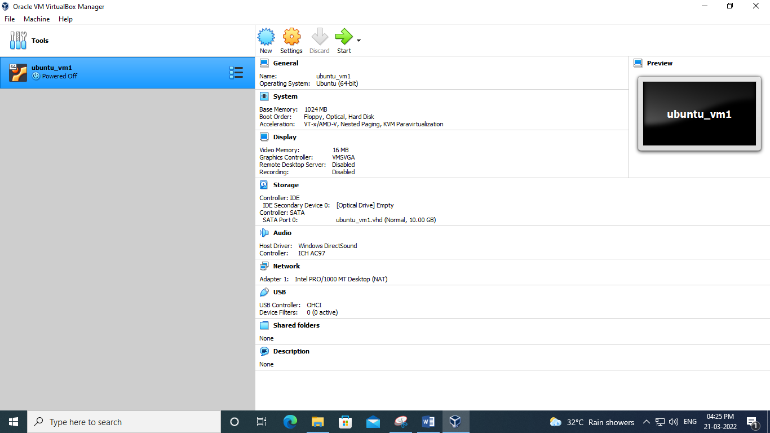

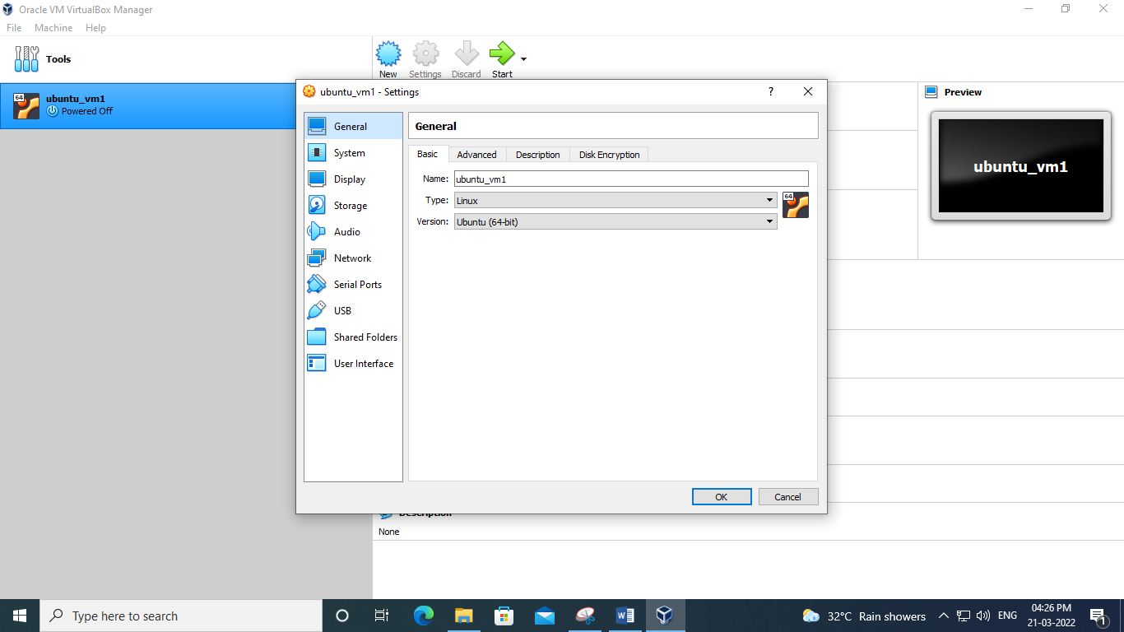

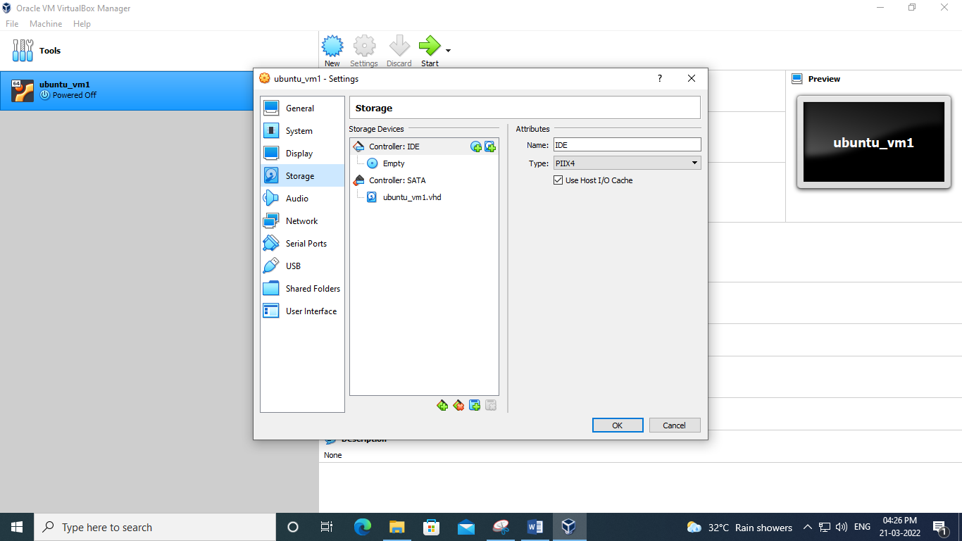

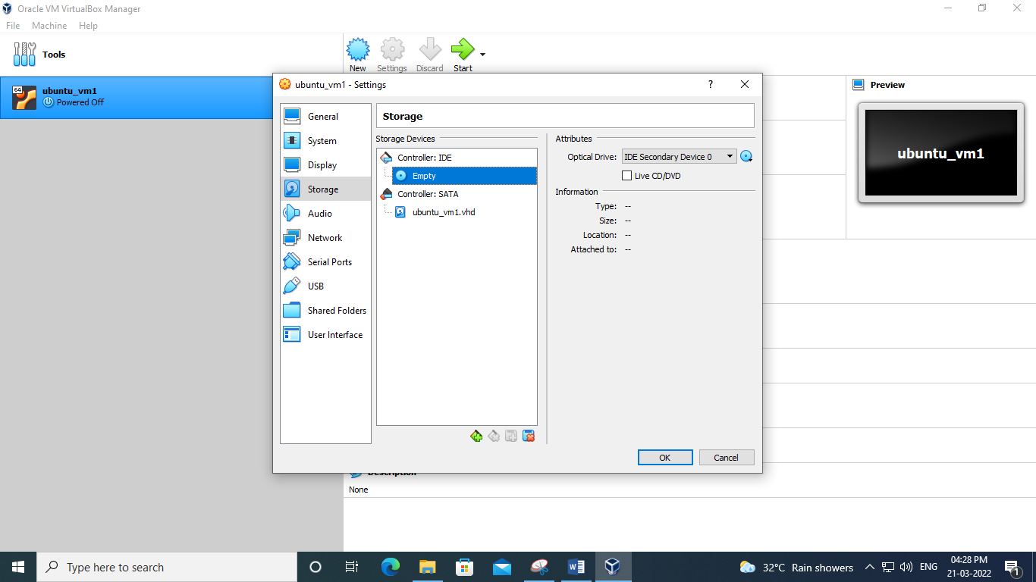

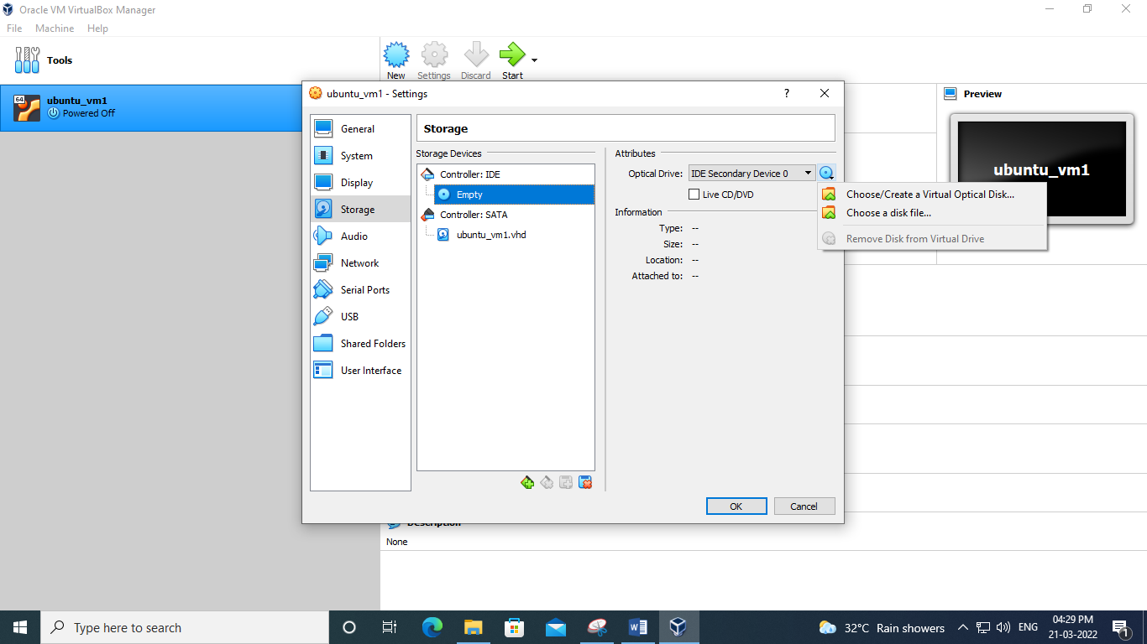

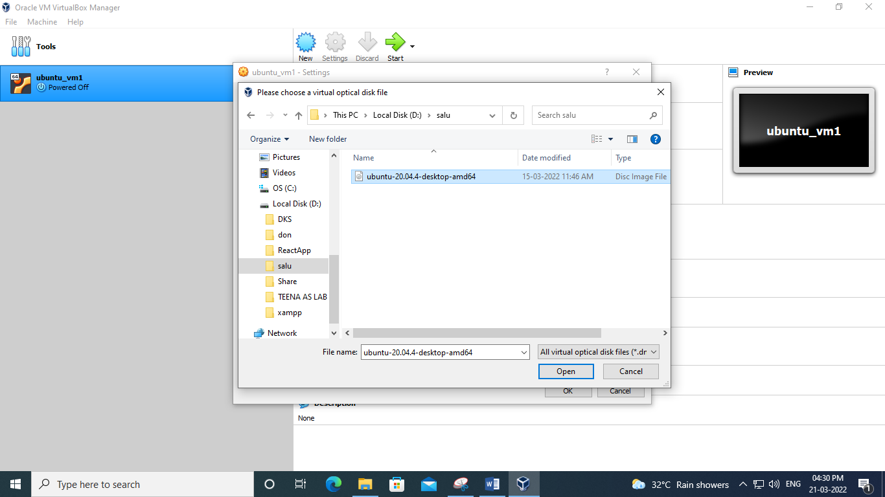

**Step 10:**VM will now boot into a live version of Ubuntu. Choose your language and select Install Ubuntu.

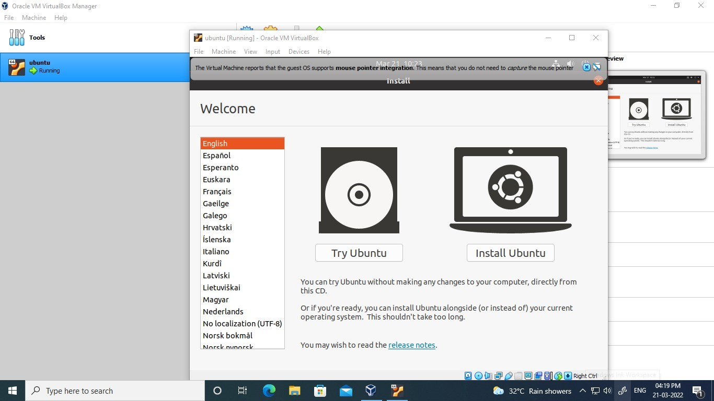

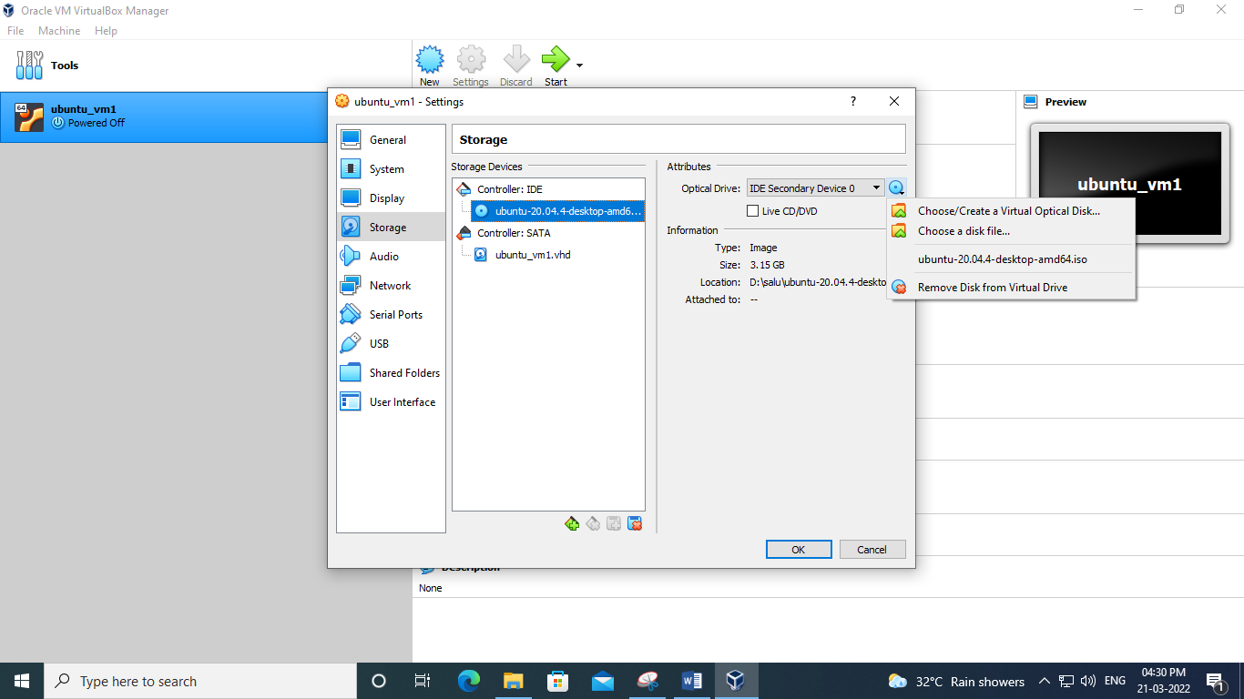

**Step 11:**Continue

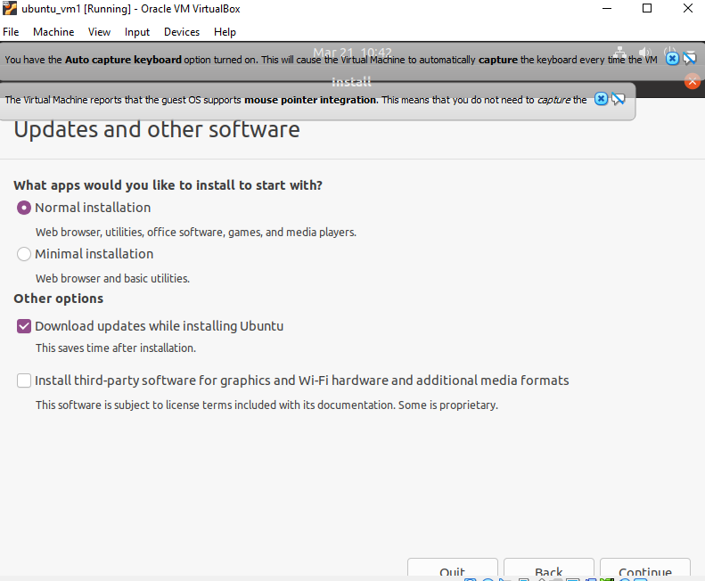

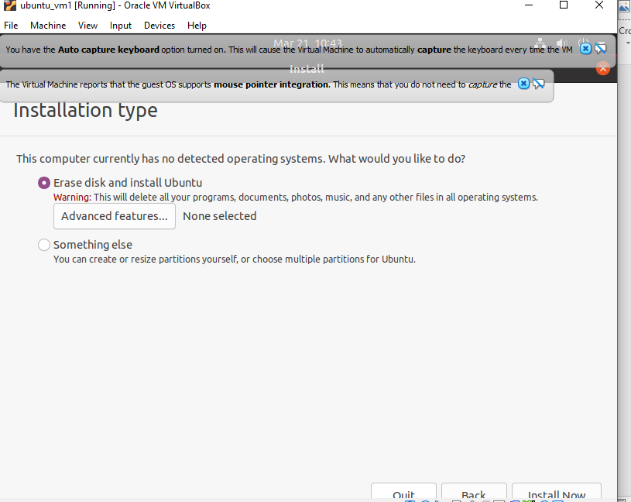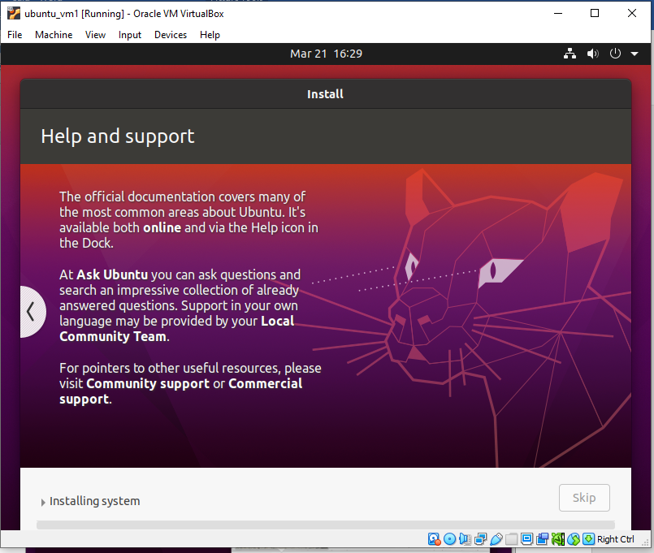

**Step 12:**Choose Erase disk and install Ubuntu and select Install Now, then select Continue to ignore the warning.

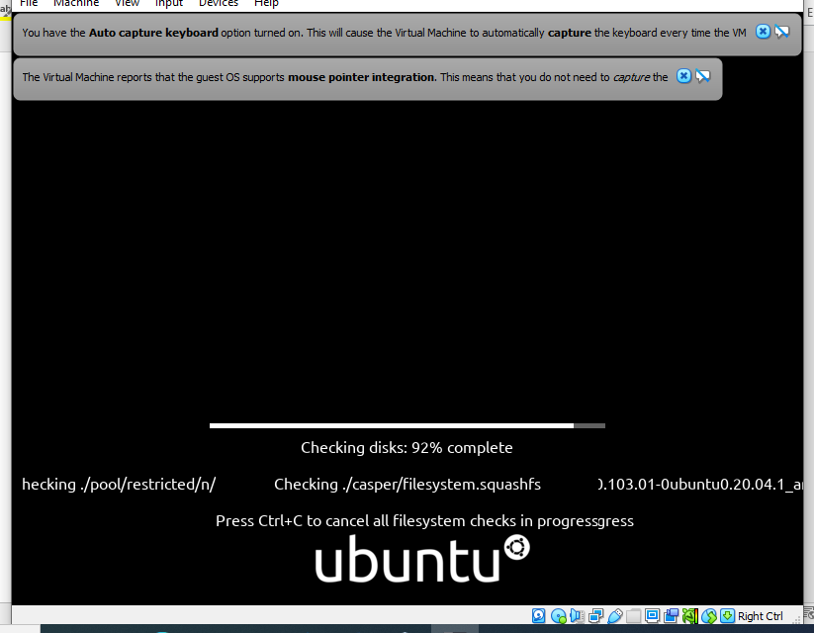

Outputscreenshot

